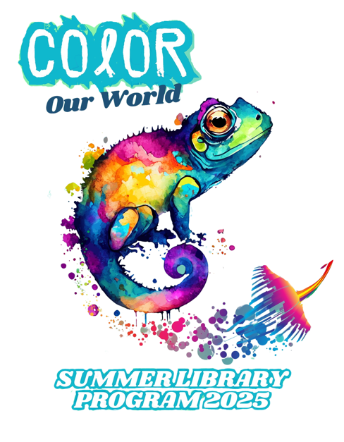
FOR IMMEDIATE RELEASE
May 1, 2025
Stephanie Packer, PR & Marketing Specialist
228-769-3130
pr@jgrls.org
Jackson-George Regional Library
3214 Pascagoula St.
Pascagoula, MS 39567
Summer Programs for All Ages at JGRLS Celebrate “Color Our World” Theme
Pascagoula, MS – The Jackson-George Regional Library System is excited to present its annual Summer Library Program, taking place June 9th through July 3rd, with various times and locations across all library branches. This year’s theme, “Color Our World,” celebrates imagination, creativity, and diversity through a vibrant lineup of free programs and special guests for children, teens, and adults.
Families can explore an engaging world of storytelling, music, nature, and entertainment, all designed to inspire a love of reading and lifelong learning. A full calendar of events and kickoff celebrations is available at www.jgrls.org.
“Every year, more and more children and families participate in our programs,” said Bethany Carlisle, JGRLS Youth Services Coordinator. “We are especially excited about this year’s theme because it encourages creativity, inclusiveness, and exploration through fun learning experiences. Whether you're new to the area or a long-time library user, there’s something for everyone!”
Programs for elementary students will take place at various branches throughout June and early July, including:
- Nature’s Color with Grand Bay NERR and Pascagoula Audubon Center
- Colorful Stories with storytellers Micki Lofton and Bethany Carlisle
- Colorful Entertainment featuring juggler and comedian Wink Danenburg
- Color Our World with Music with musician Gram Rea
Program dates and times vary by location. Many events include door prize giveaways generously provided by local businesses and Friends of the Library groups.
Families are encouraged to get a library card and join in the summer reading challenge, along with weekly branch events designed for all ages.
Visit www.jgrls.org or follow @JacksonGeorgeLibrary on Facebook for the complete schedule, updates, and photos throughout the summer.

About Jackson-George Regional Library System
The Jackson-George Regional Library System proudly serves communities across Jackson and George Counties, providing free access to books, technology, educational programming, and enrichment opportunities for all ages. Through innovation and community partnerships, JGRLS empowers lifelong learning and imagination.

